**APPENDICES**

**APPENDIX A**

Request Letter

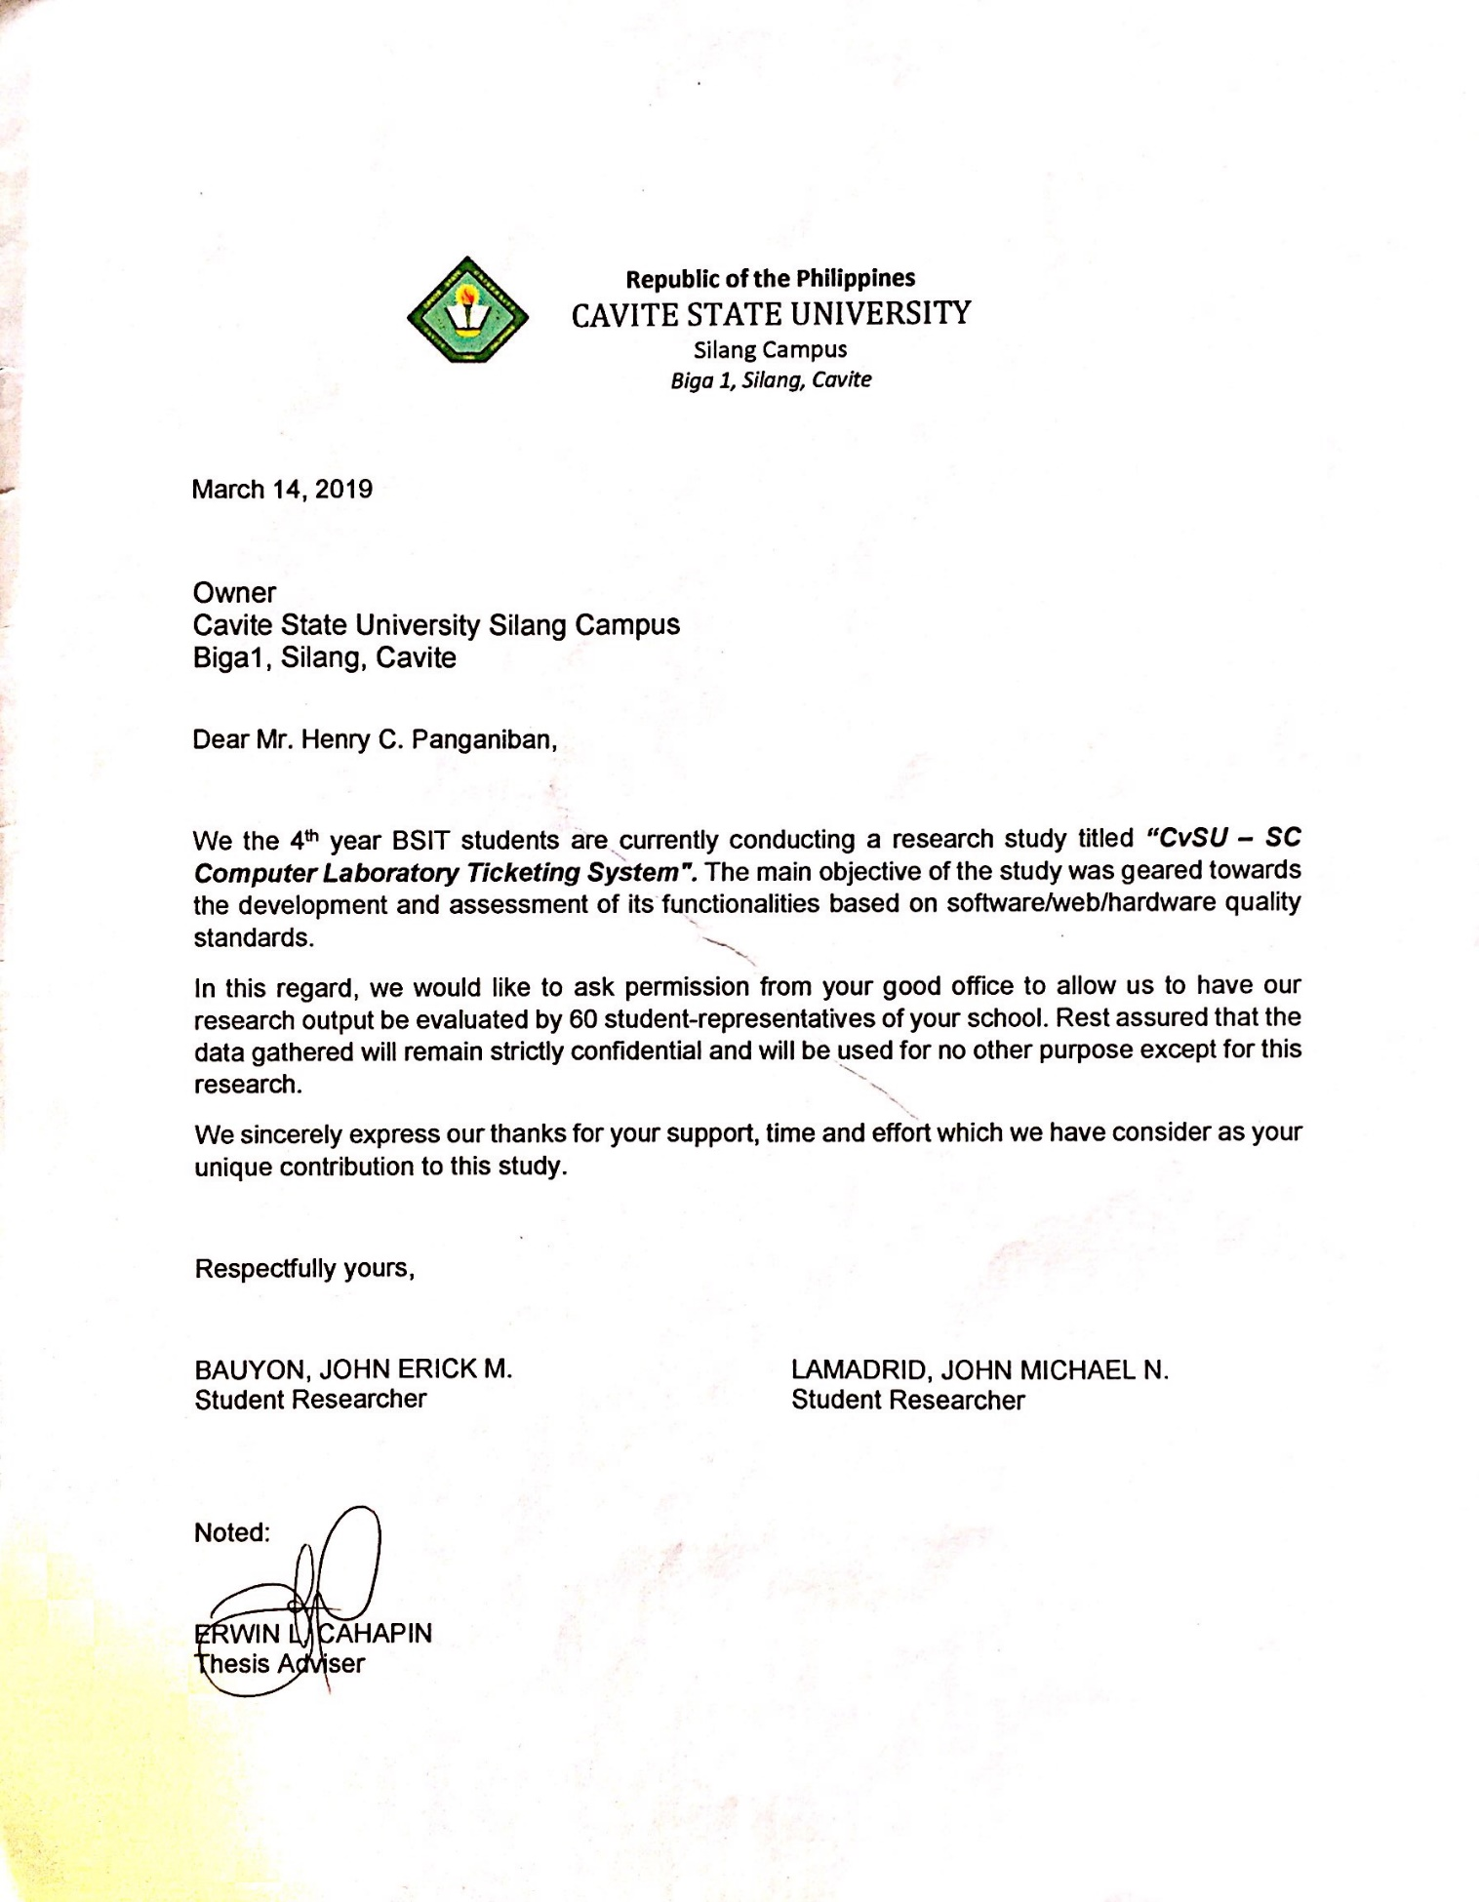

**APPENDIX B**

Certifications

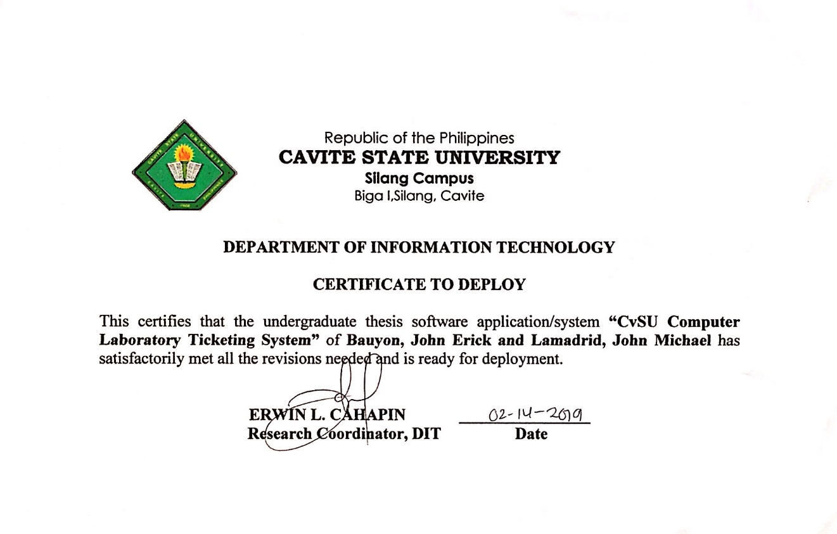

**APPENDIX C**

Sample Evaluation Instrument

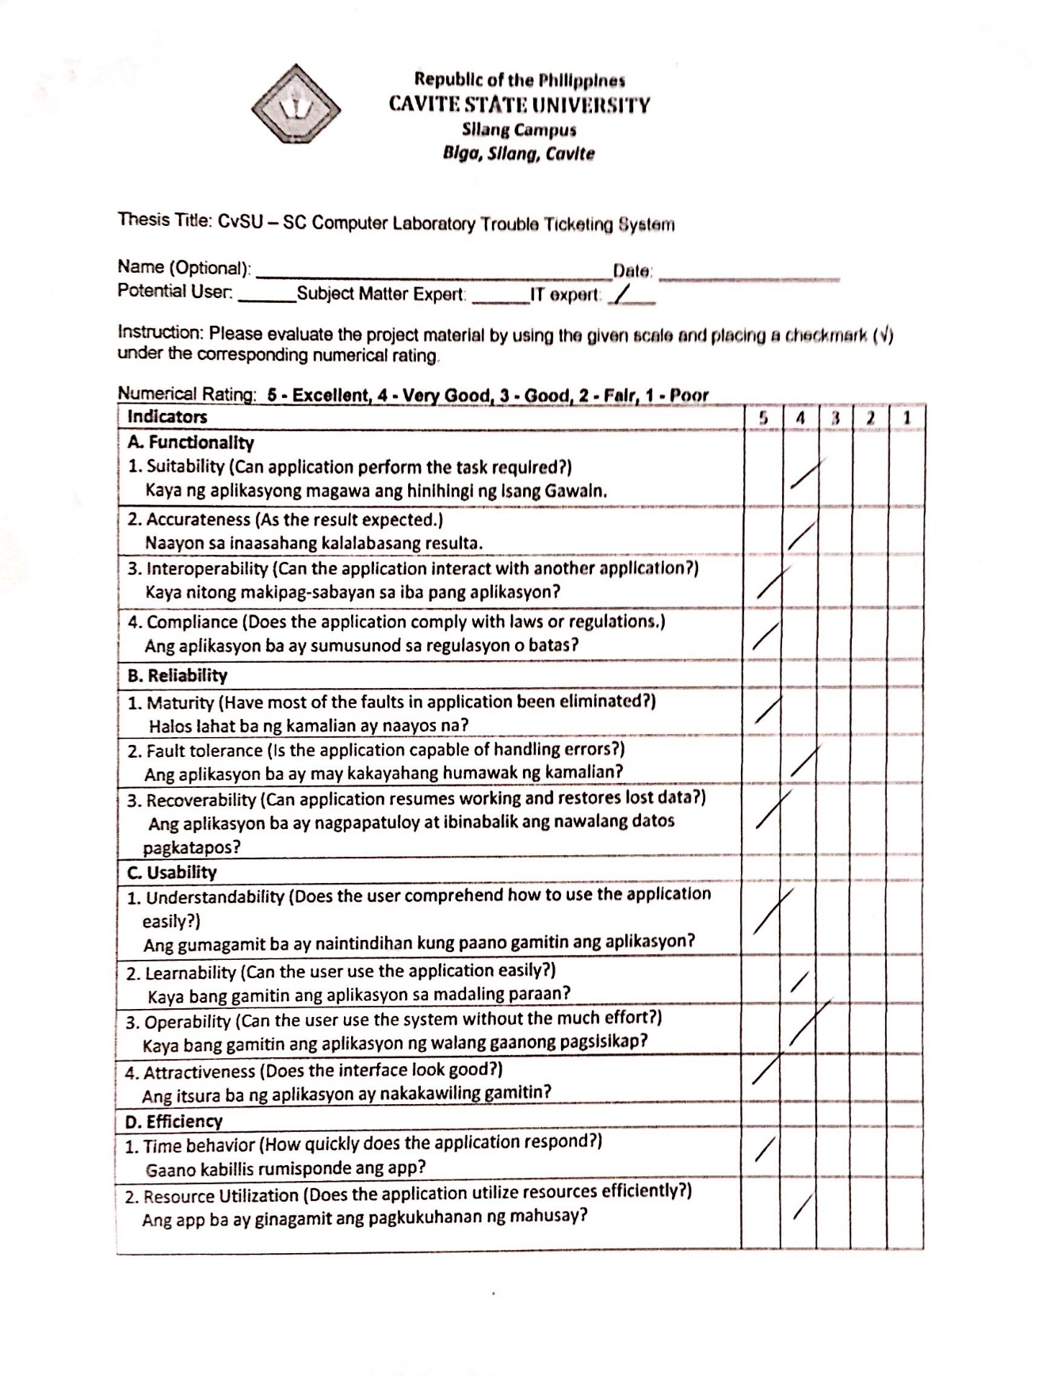

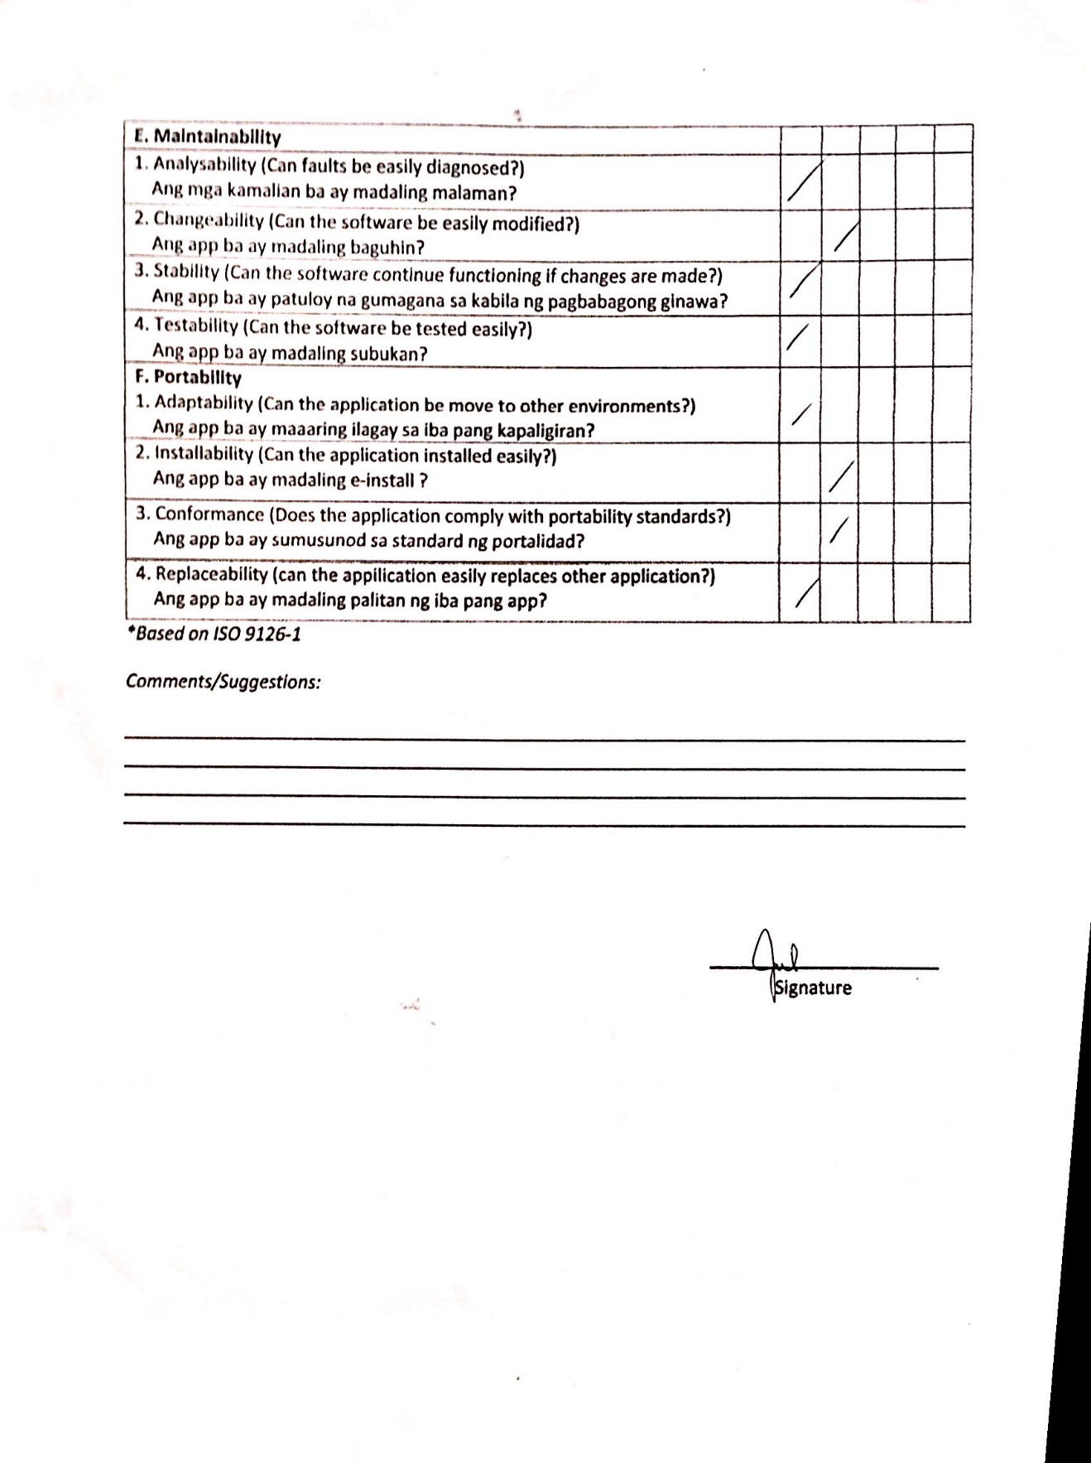

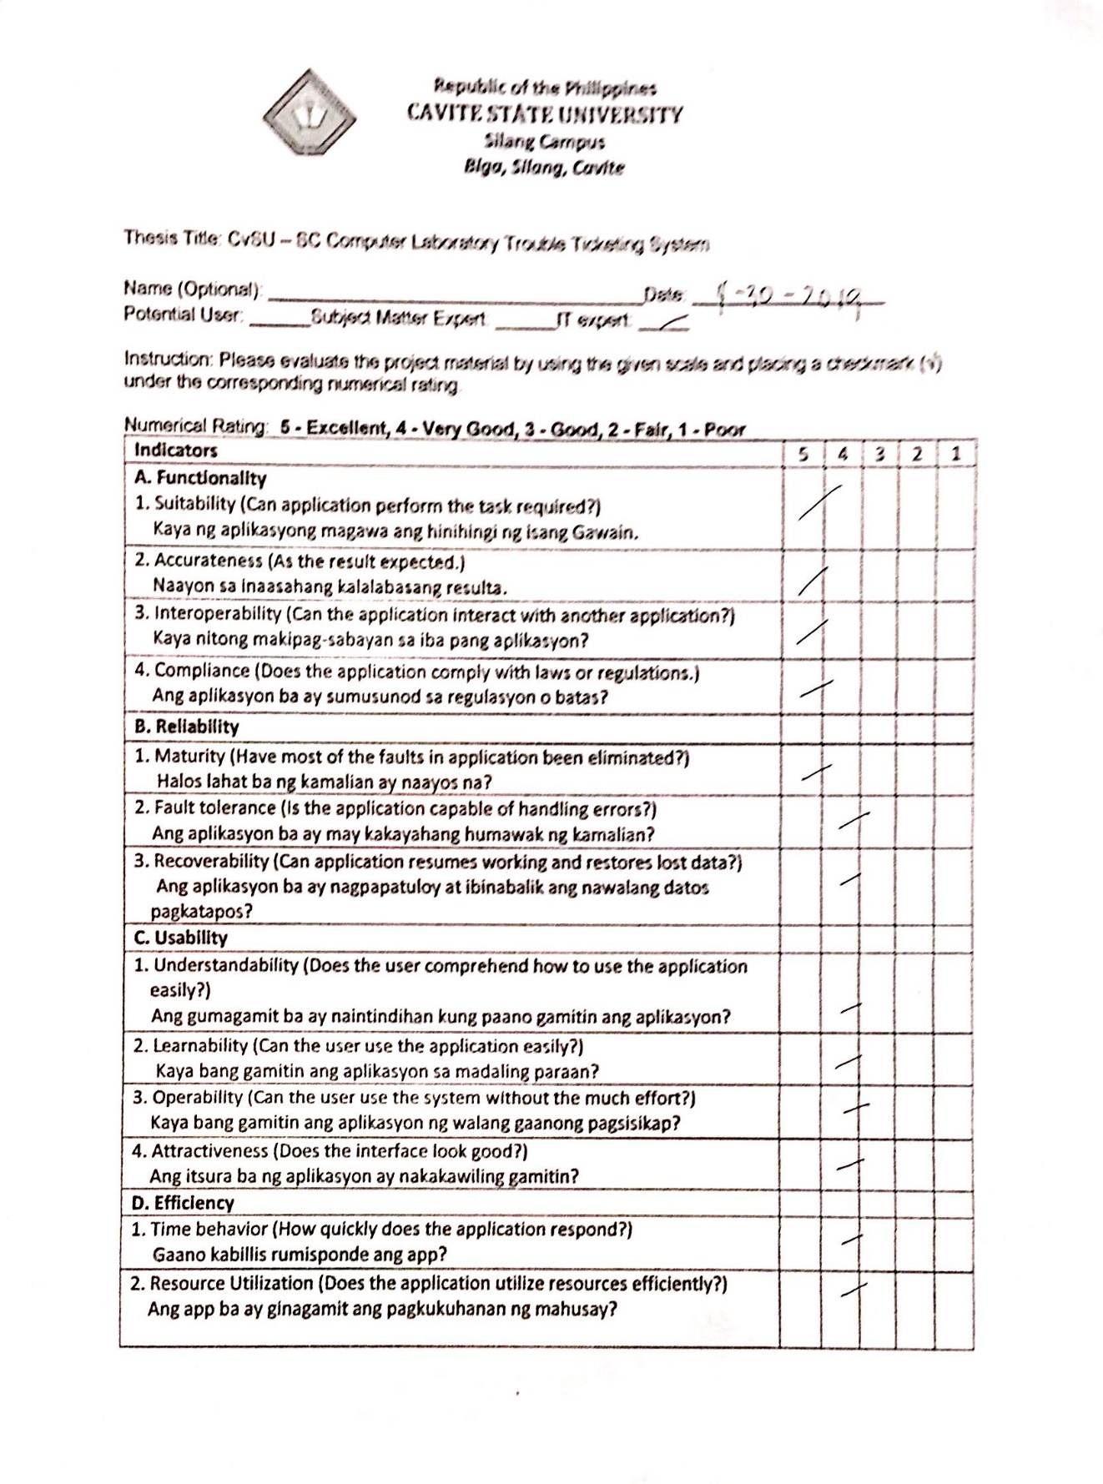

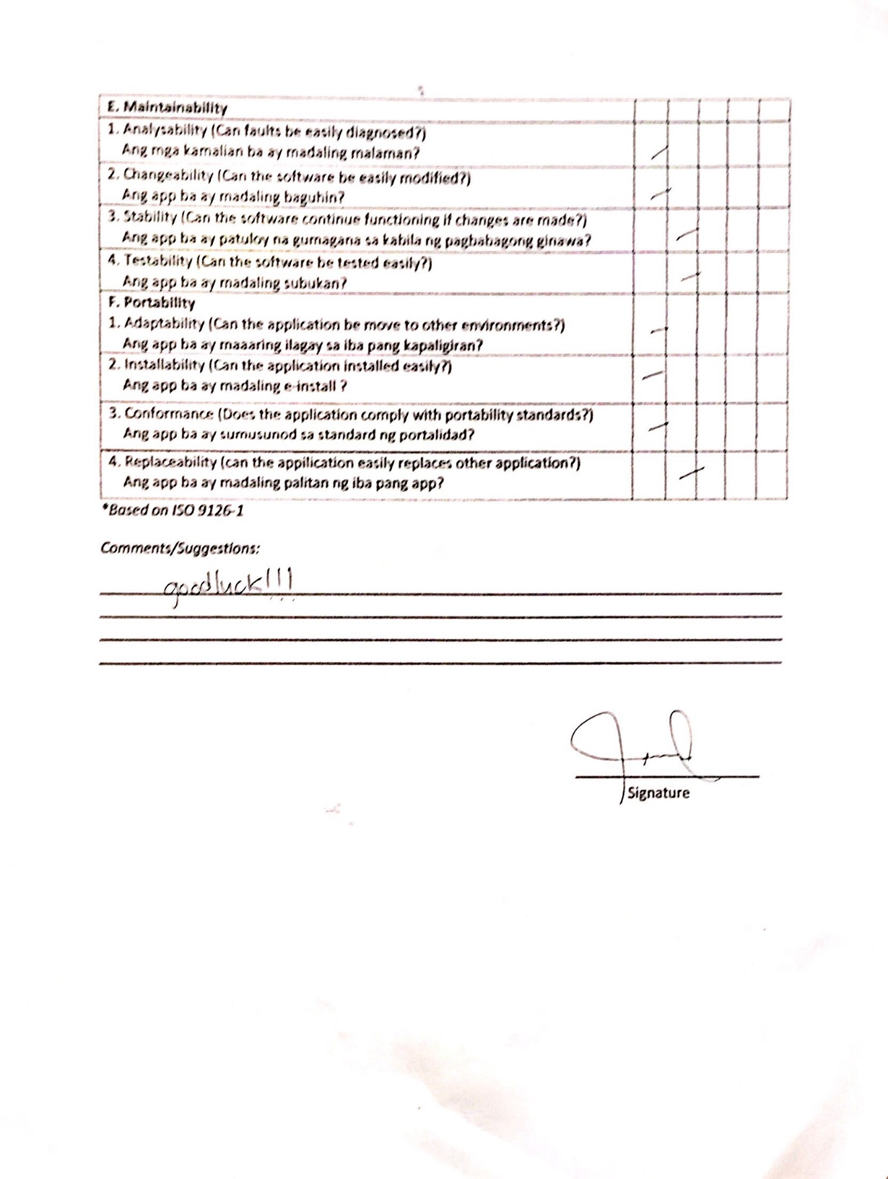

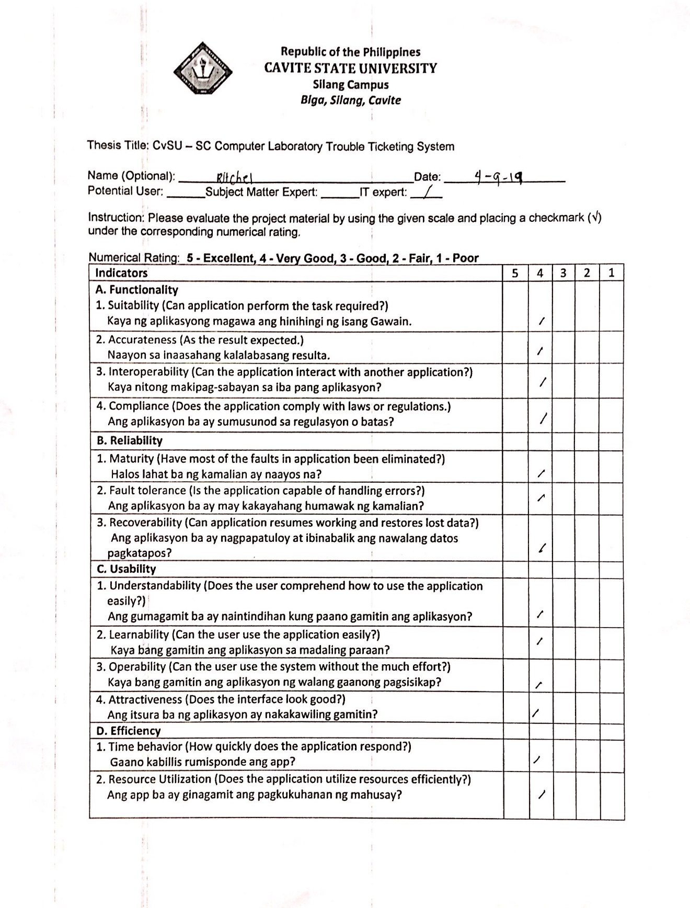

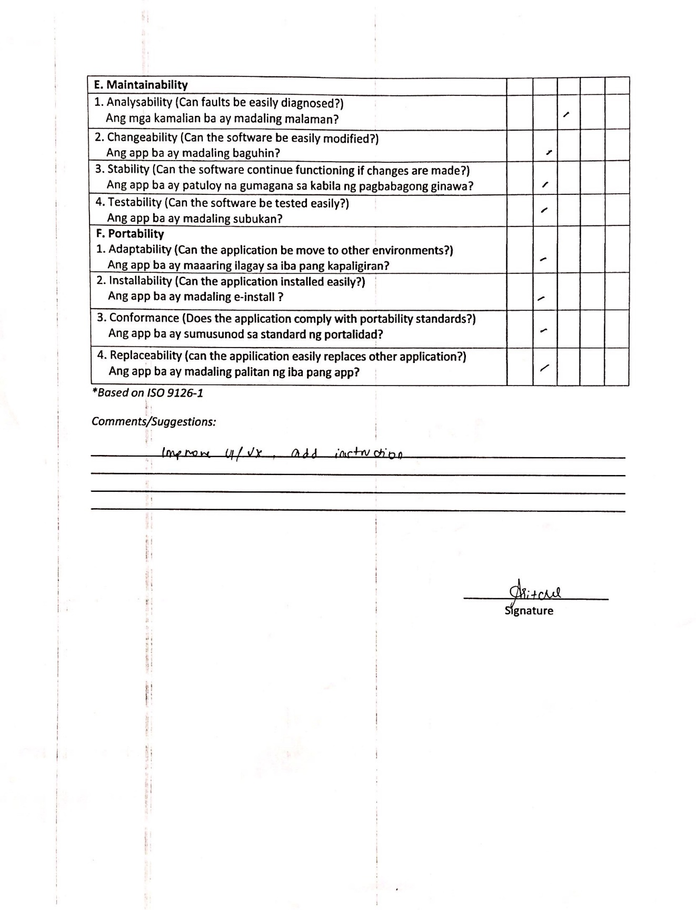

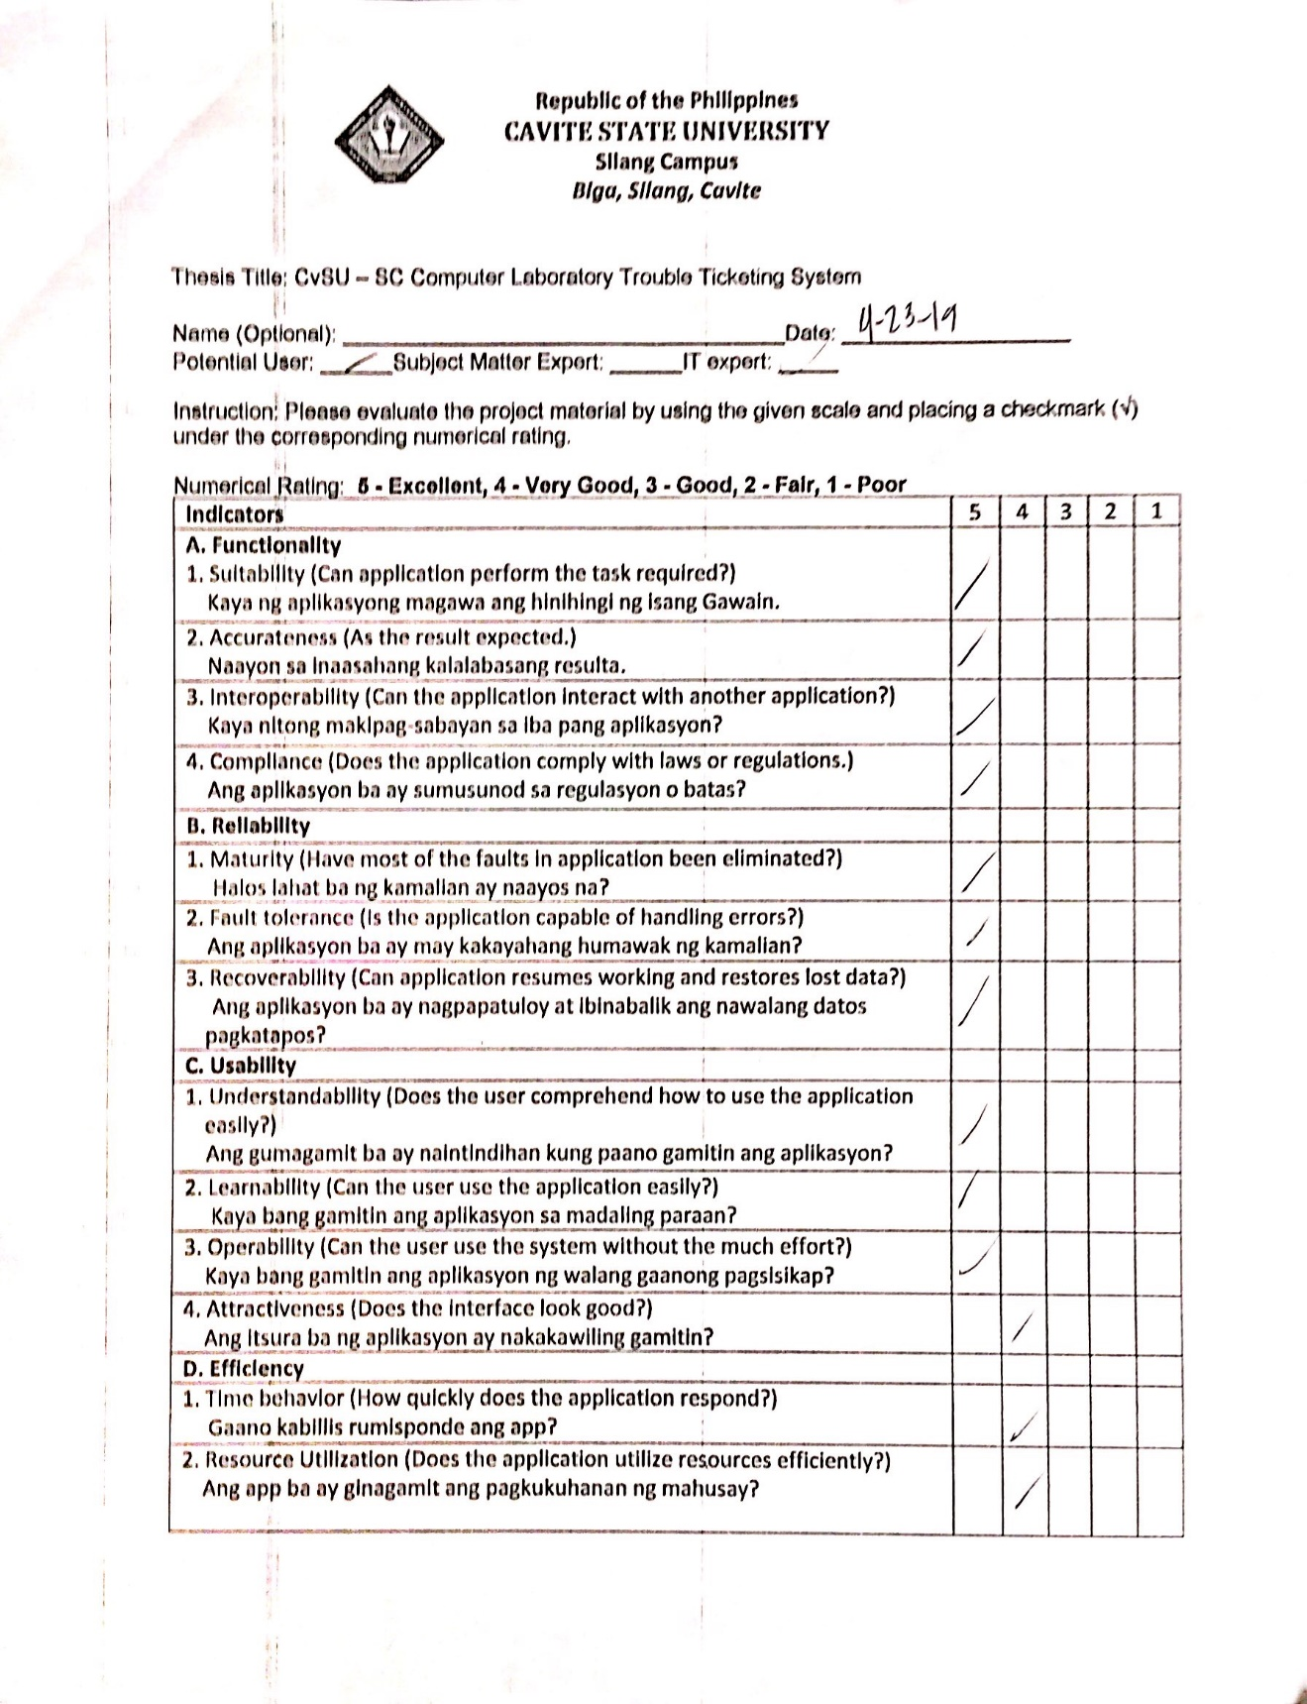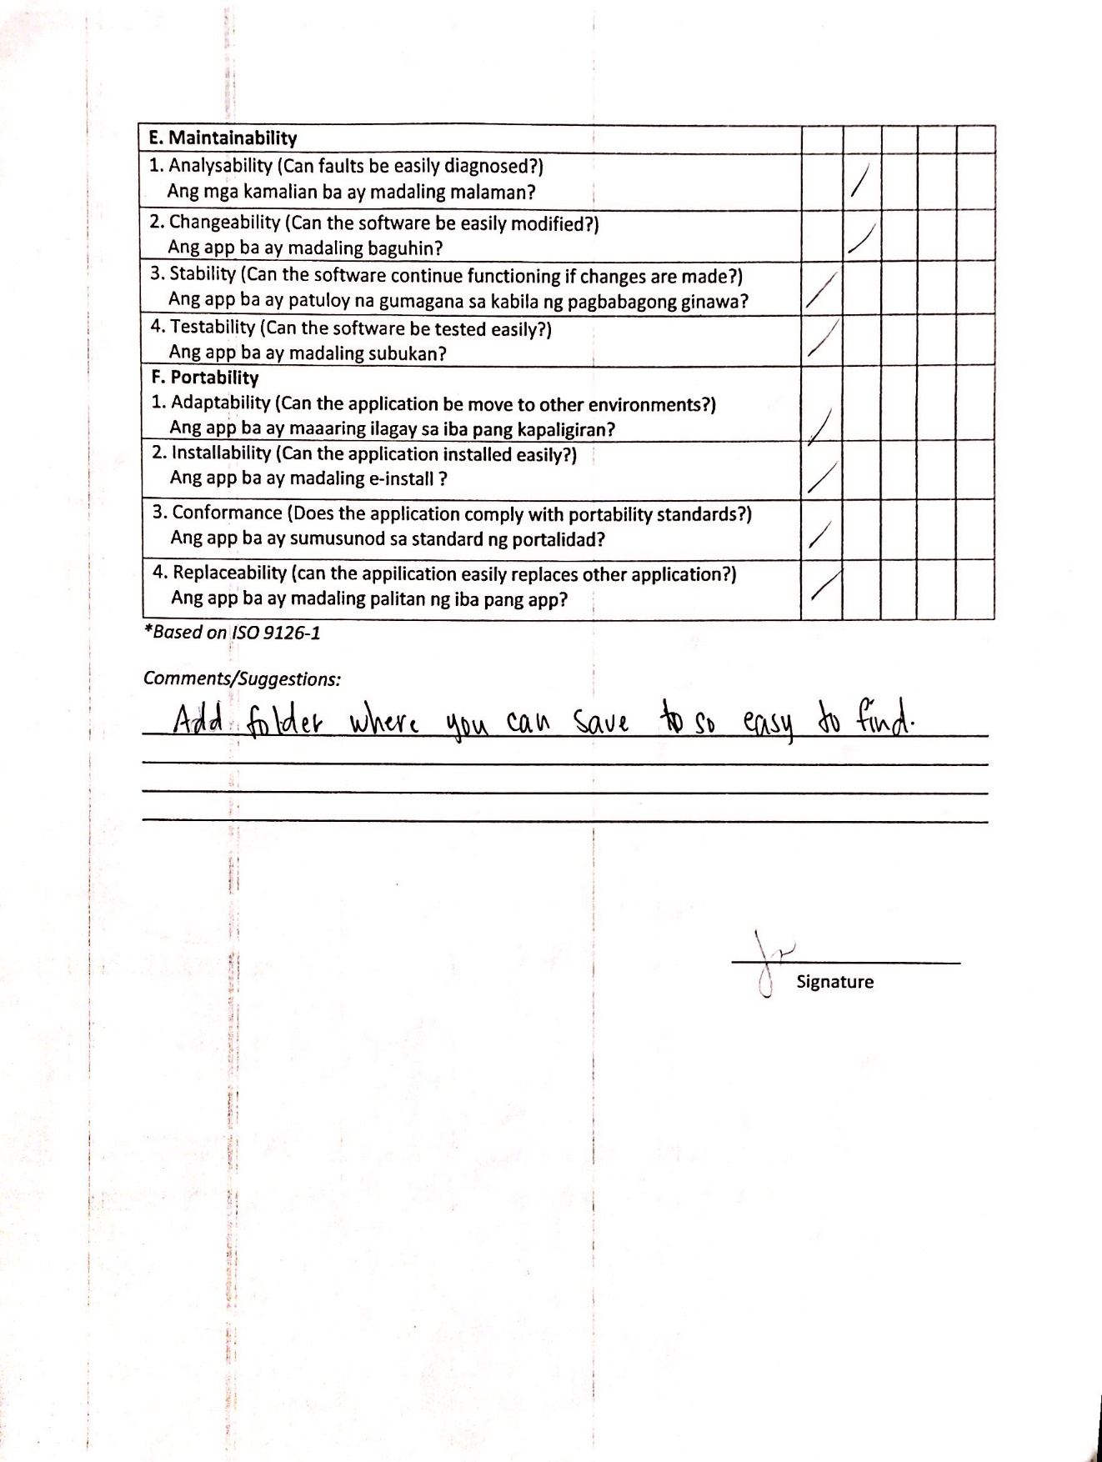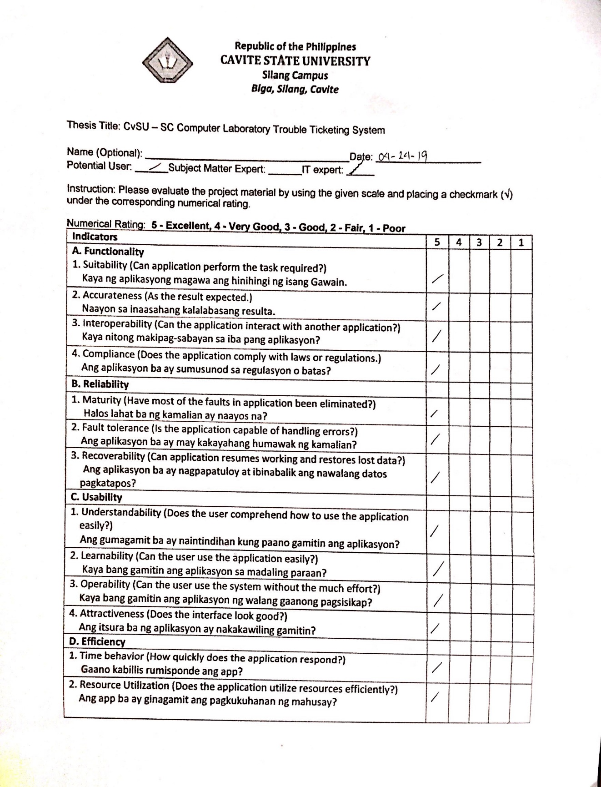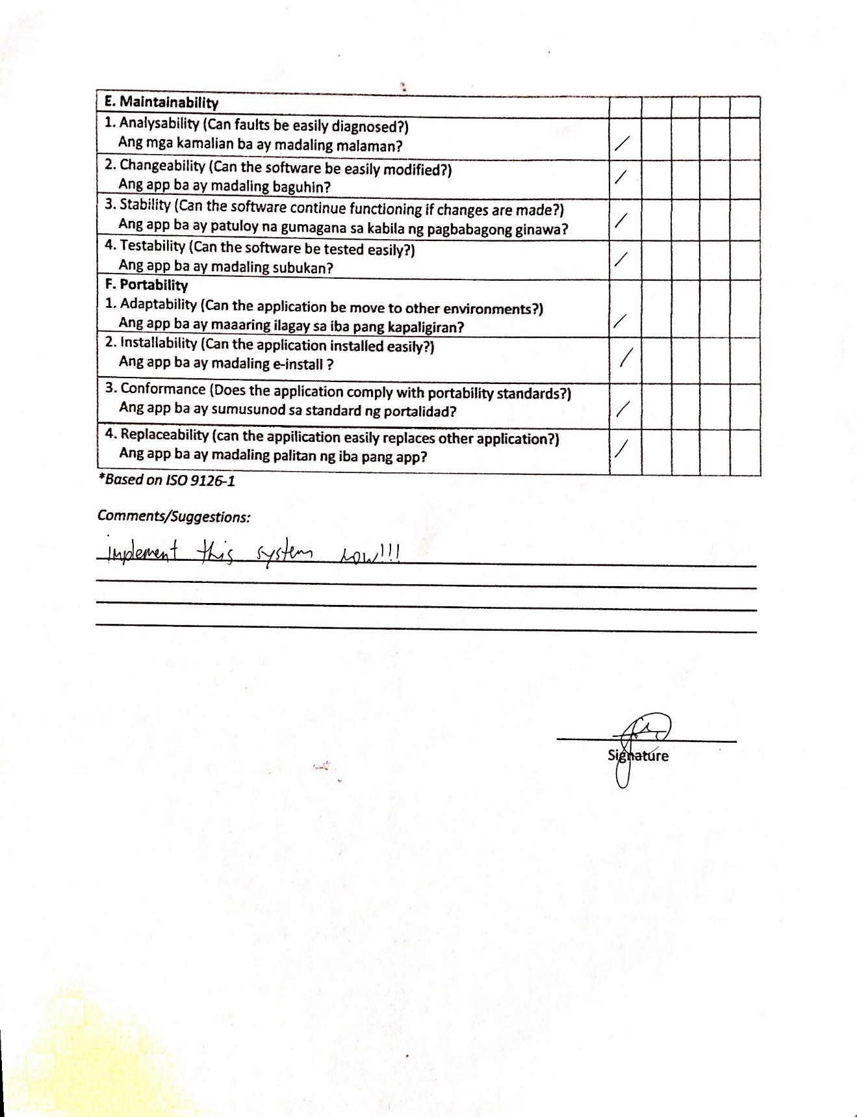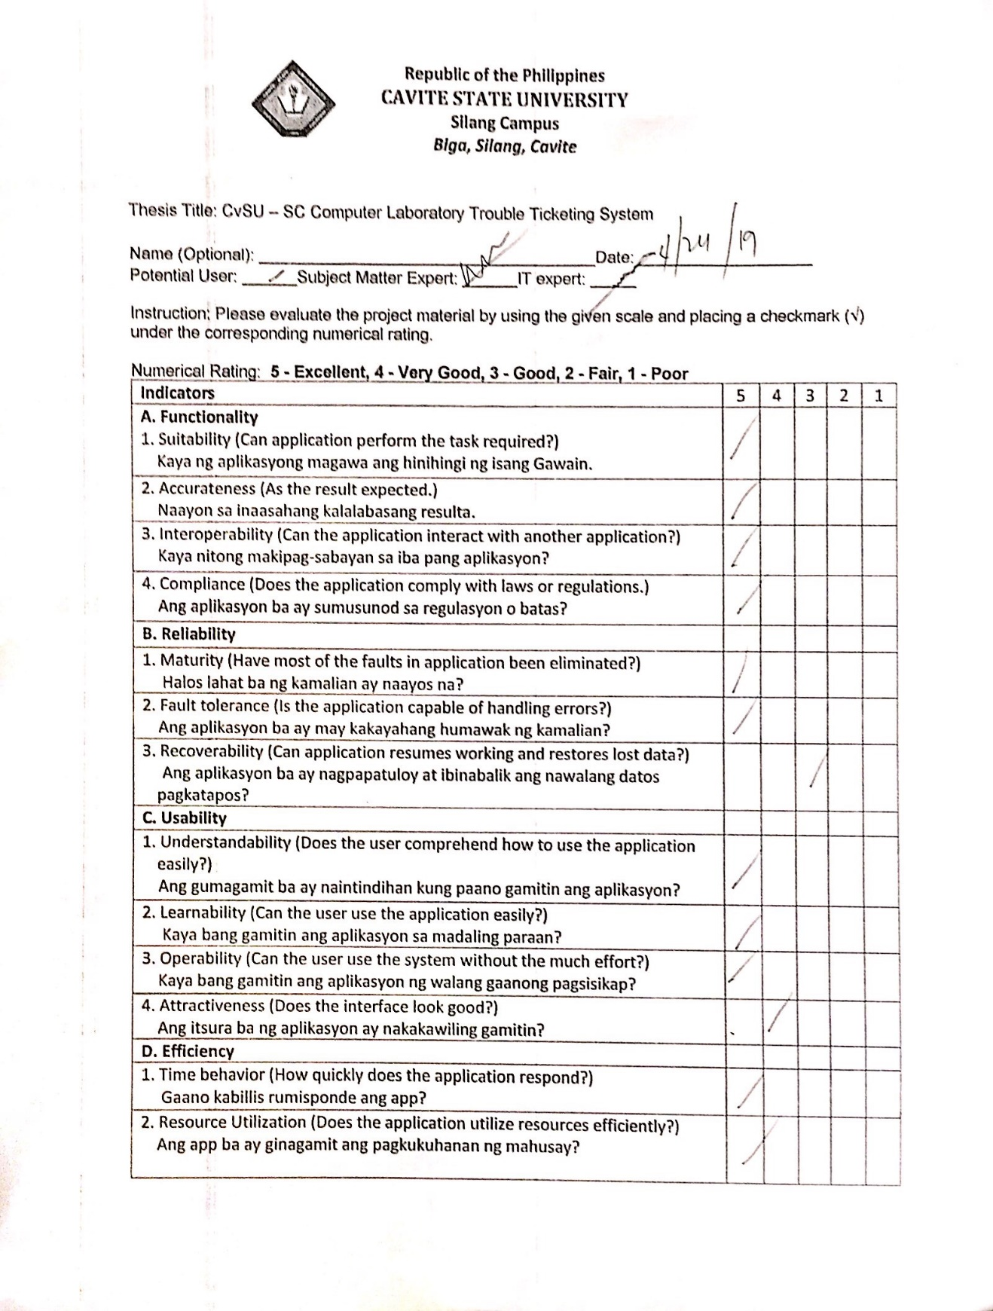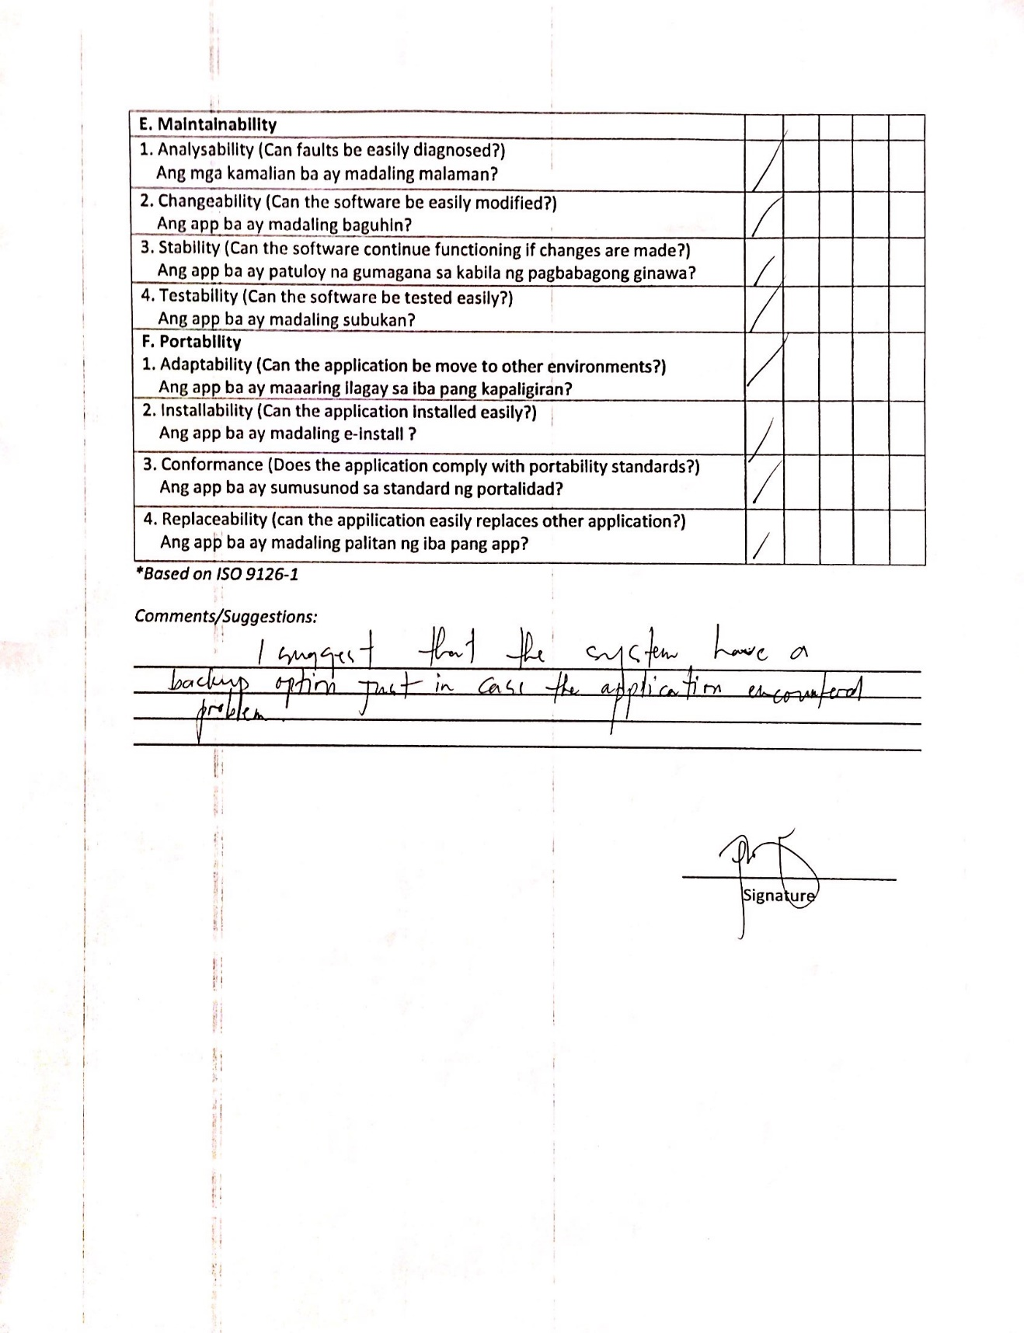

**APPENDIX D**

Time Table of Activities

**APPENDIX E**

Budgeting Estimate

|  |  |
| --- | --- |
| PARTICULARS | AMOUNT |
| 1. Maintenance and other Operating Expenses (MOOE) |  |
| 1.1 Electric Bill | Php 5,000.00 |
| 1.2 Transportation and Food Expenses | Php 5,000.00 |
| 1.3 Internet Connection | Php 2,800.00 |
| 1.4 Materials and Supplies | Php 25,000.00 |
| Total Maintenance and other Operating Expenses | **Php 37, 800.00** |
| TOTAL BUDGET | **Php 37, 800.00** |

Appendix Table 2. Budgetary requirements.

Appendix Table 3. Bill of Materials and Supplies

|  |  |  |
| --- | --- | --- |
| **ITEMS** | **QUANTITY** | **AMOUNT (PHP)** |
| **Hardware** |  |  |
| Samsung Laptop | 1 | Php 20,000.00 |
| SSD | 1 | Php 3,000.00 |
| **Documentations** |  |  |
| Prints | 1 black and 3 colored ink |  |
|  | 3 reams | Php 2,000.00 |
| **TOTAL** |  | **Php 25,000.00** |

**APPENDIX F**

Screenshot of The Application

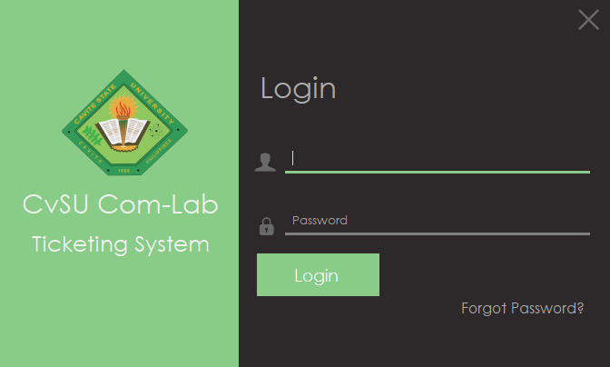

Appendix Figure 1. Login Form

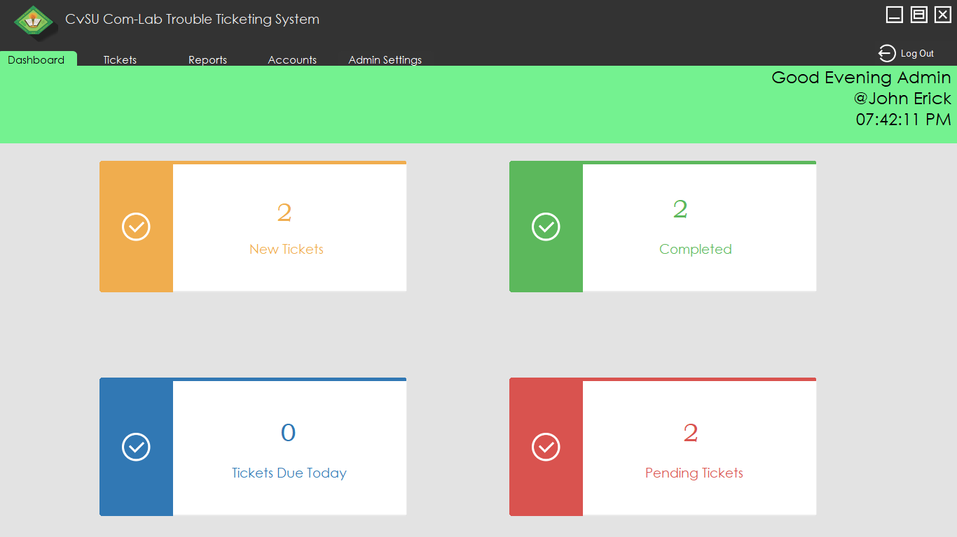

Appendix Figure 2. Admin Dashboard

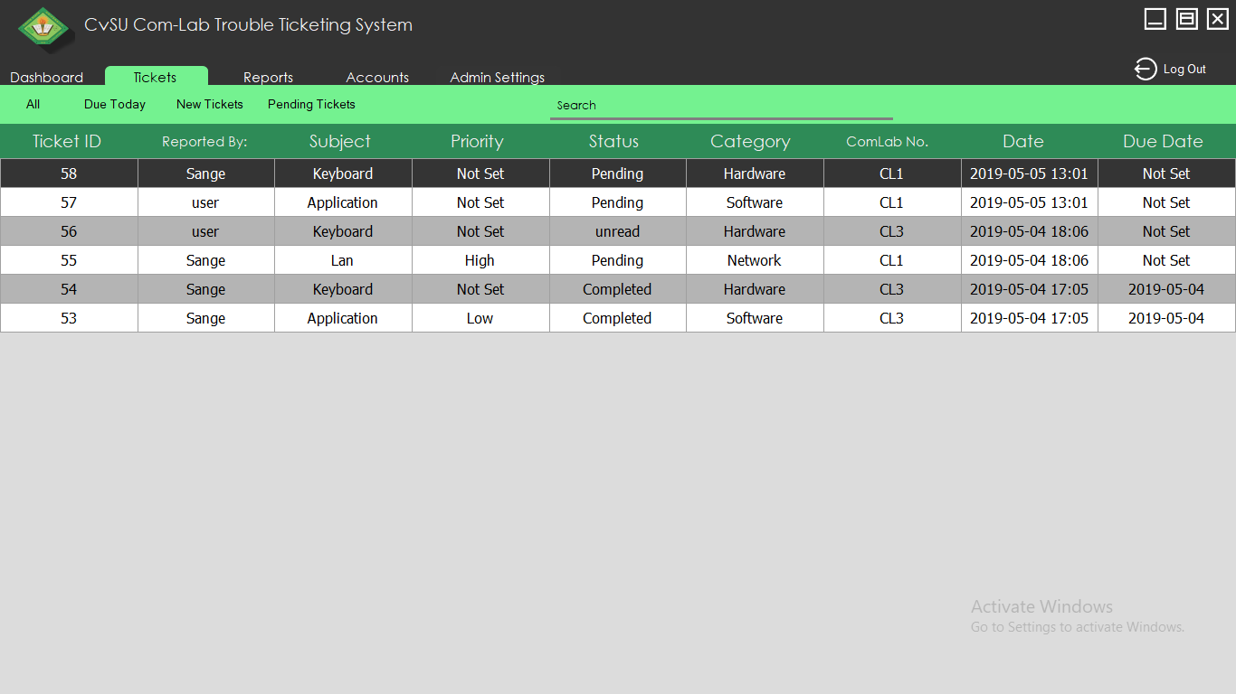

Appendix Picture 3. Admin Tickets

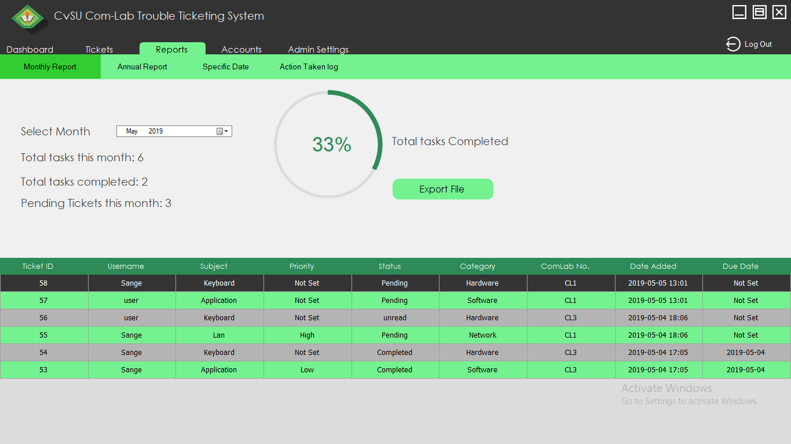

Appendix Figure 4. Reports

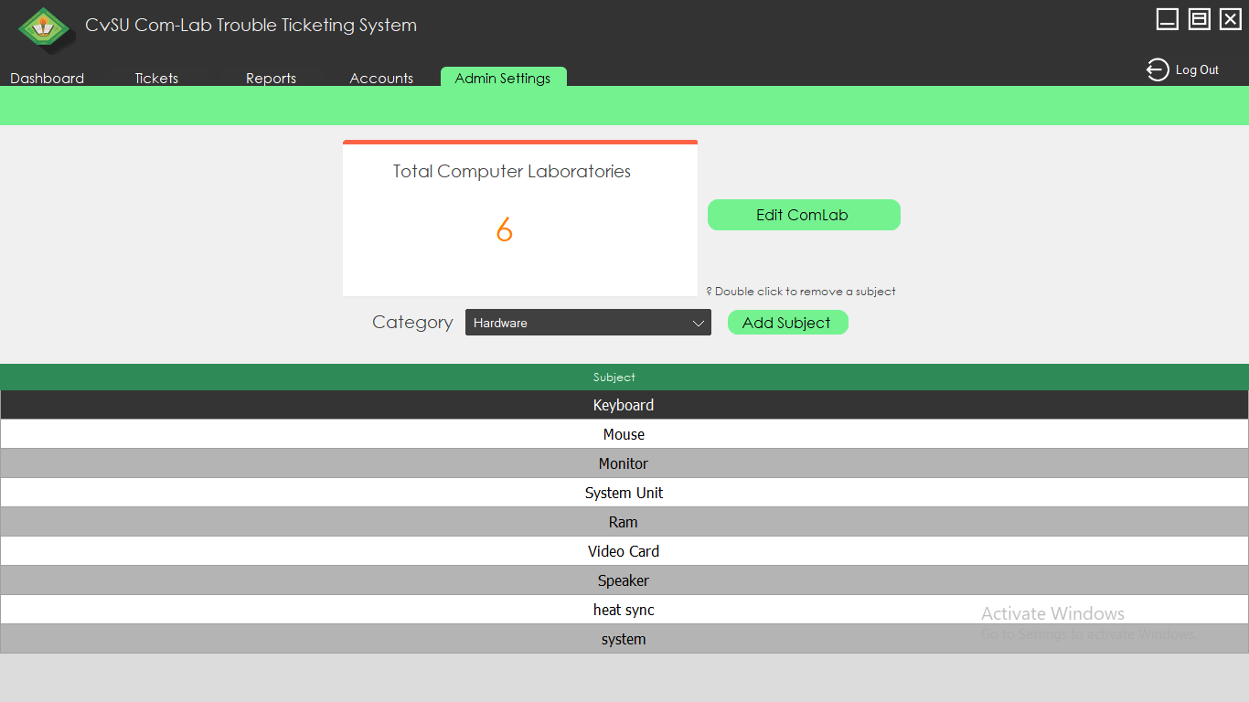

Appendix Figure 5. Admin Settings

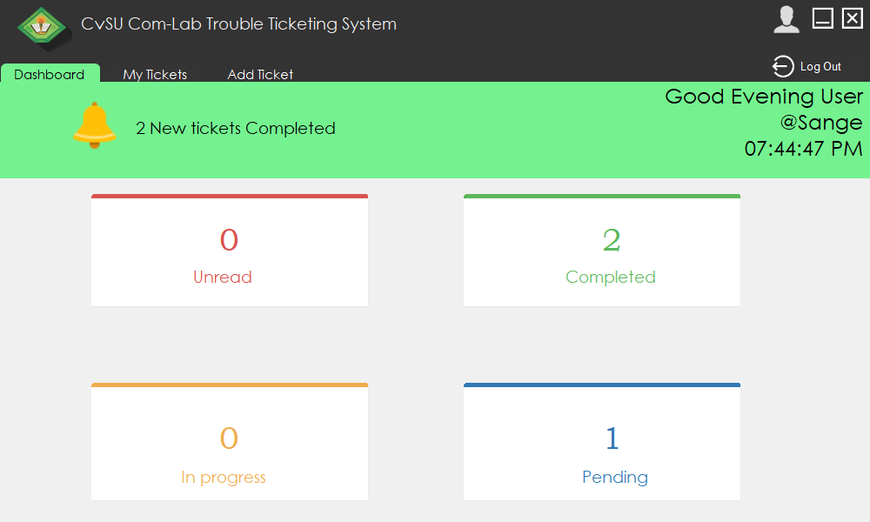

Appendix Figure 6. User Dashboard

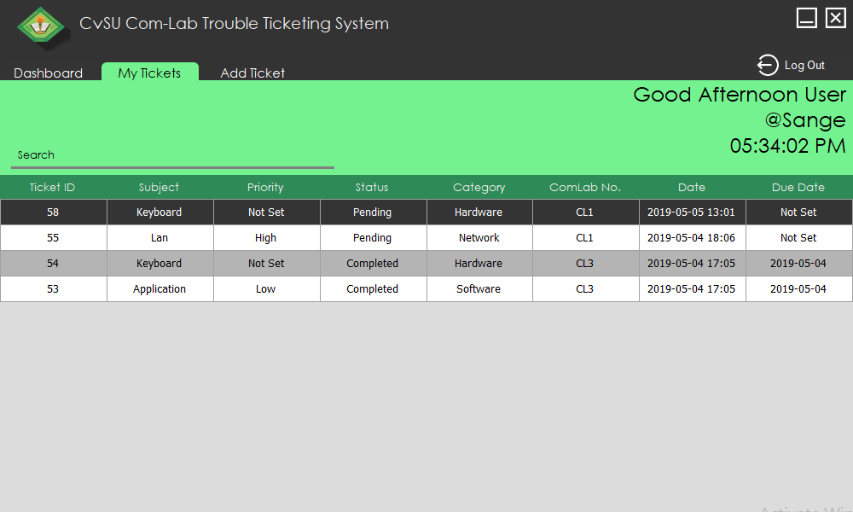

Appendix Figure 7. User Tickets

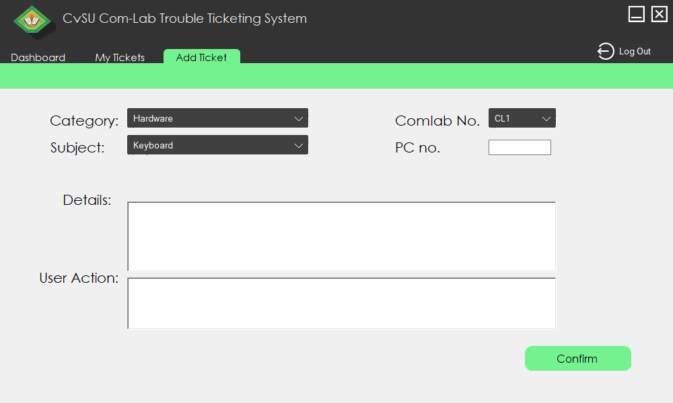

Appendix Figure 8. User adding form

**APPENDIX G**

Curriculum Vitae

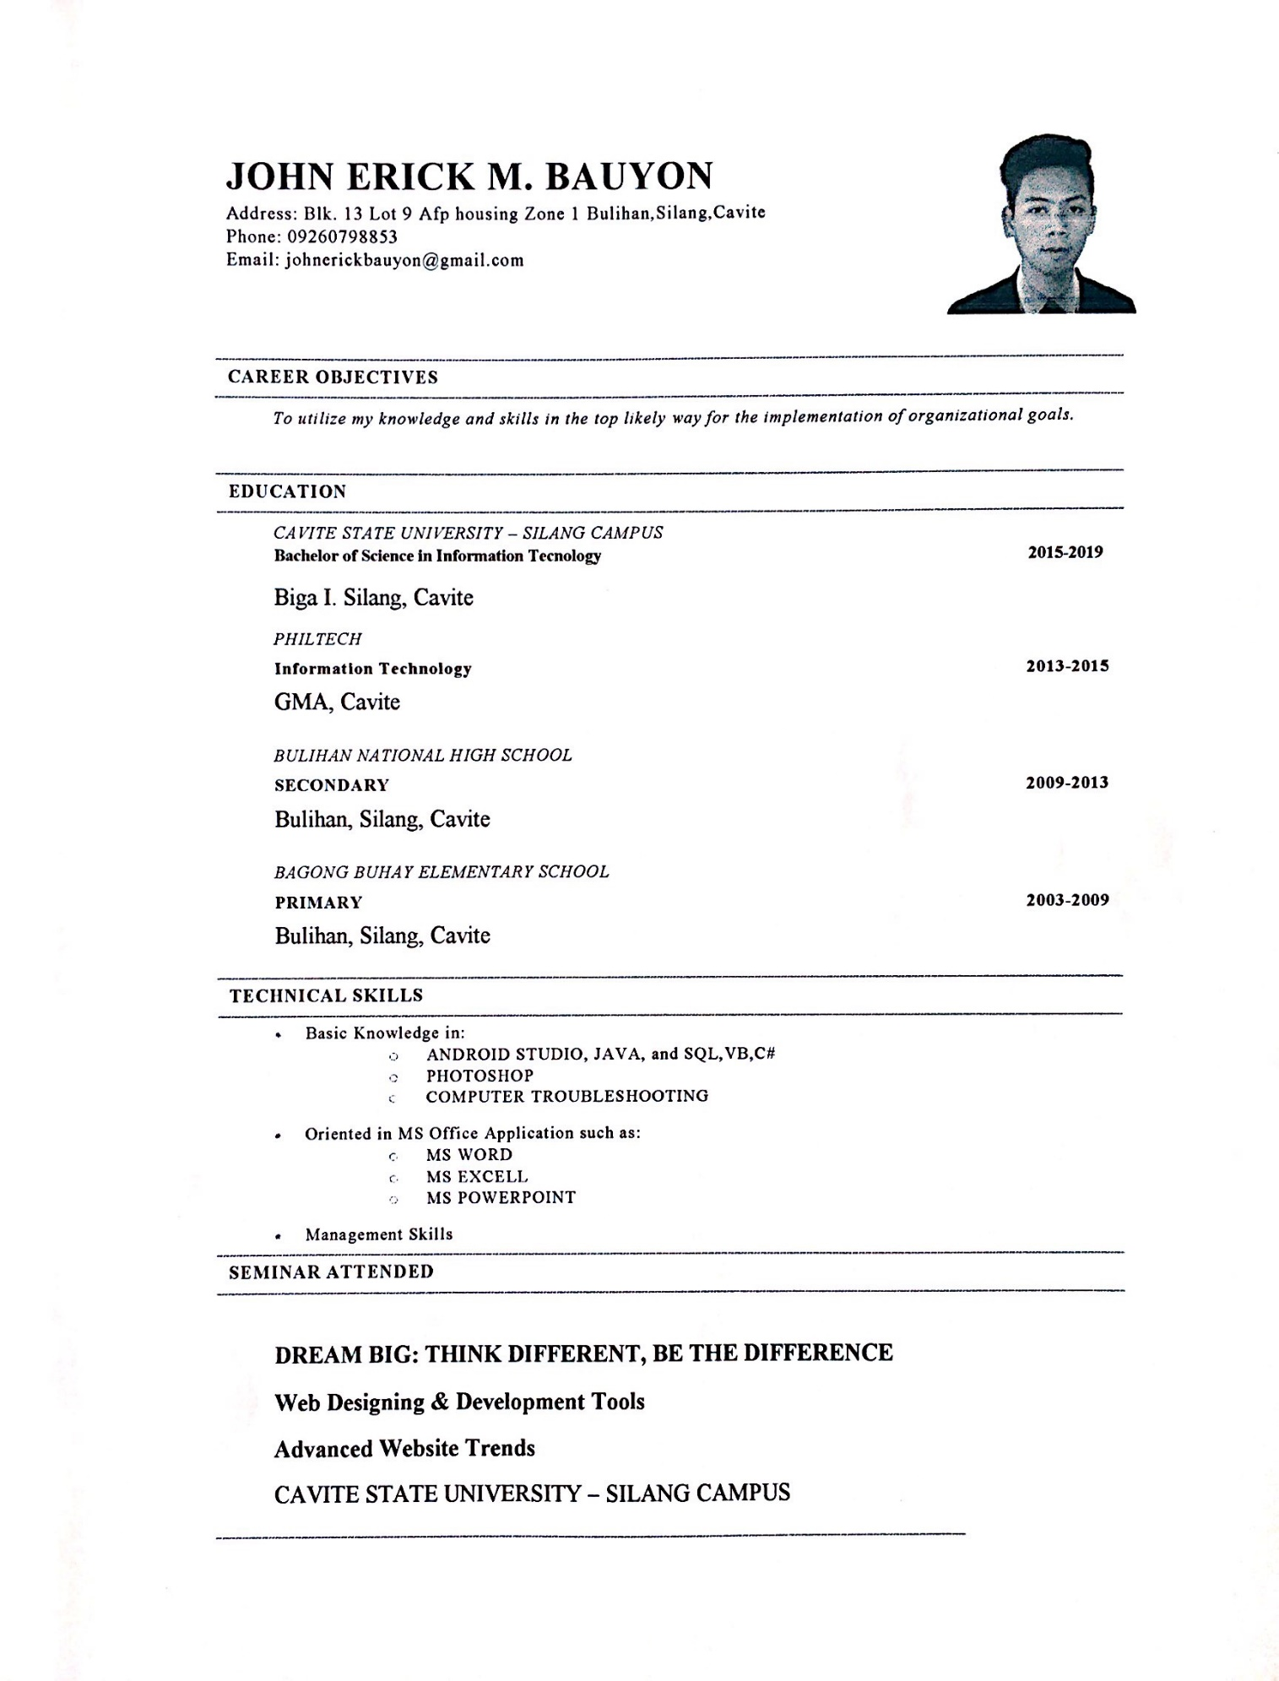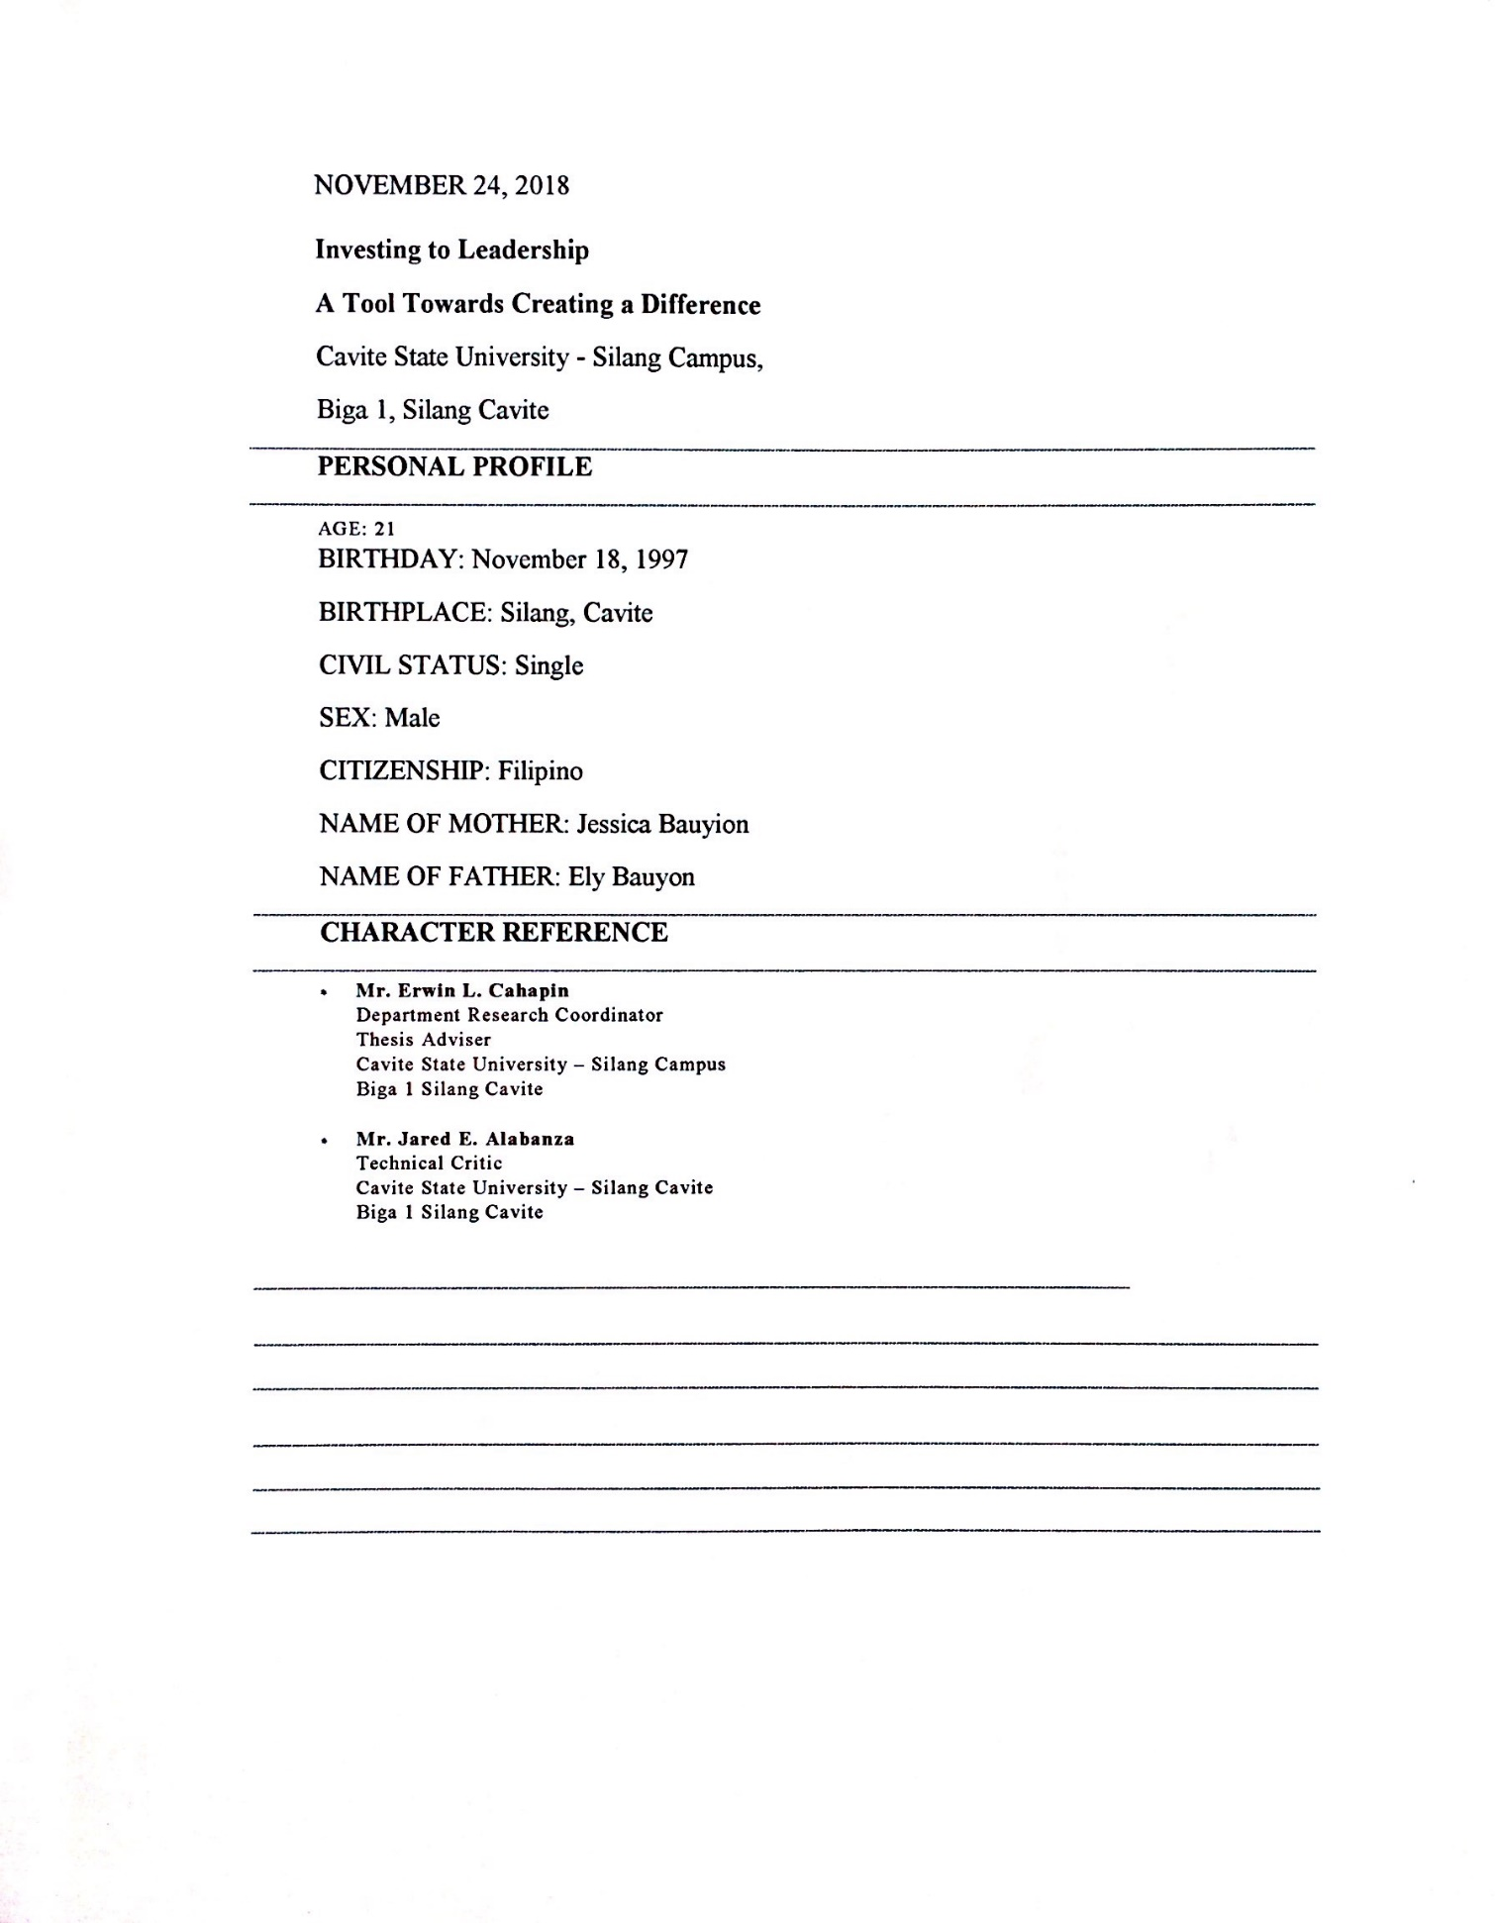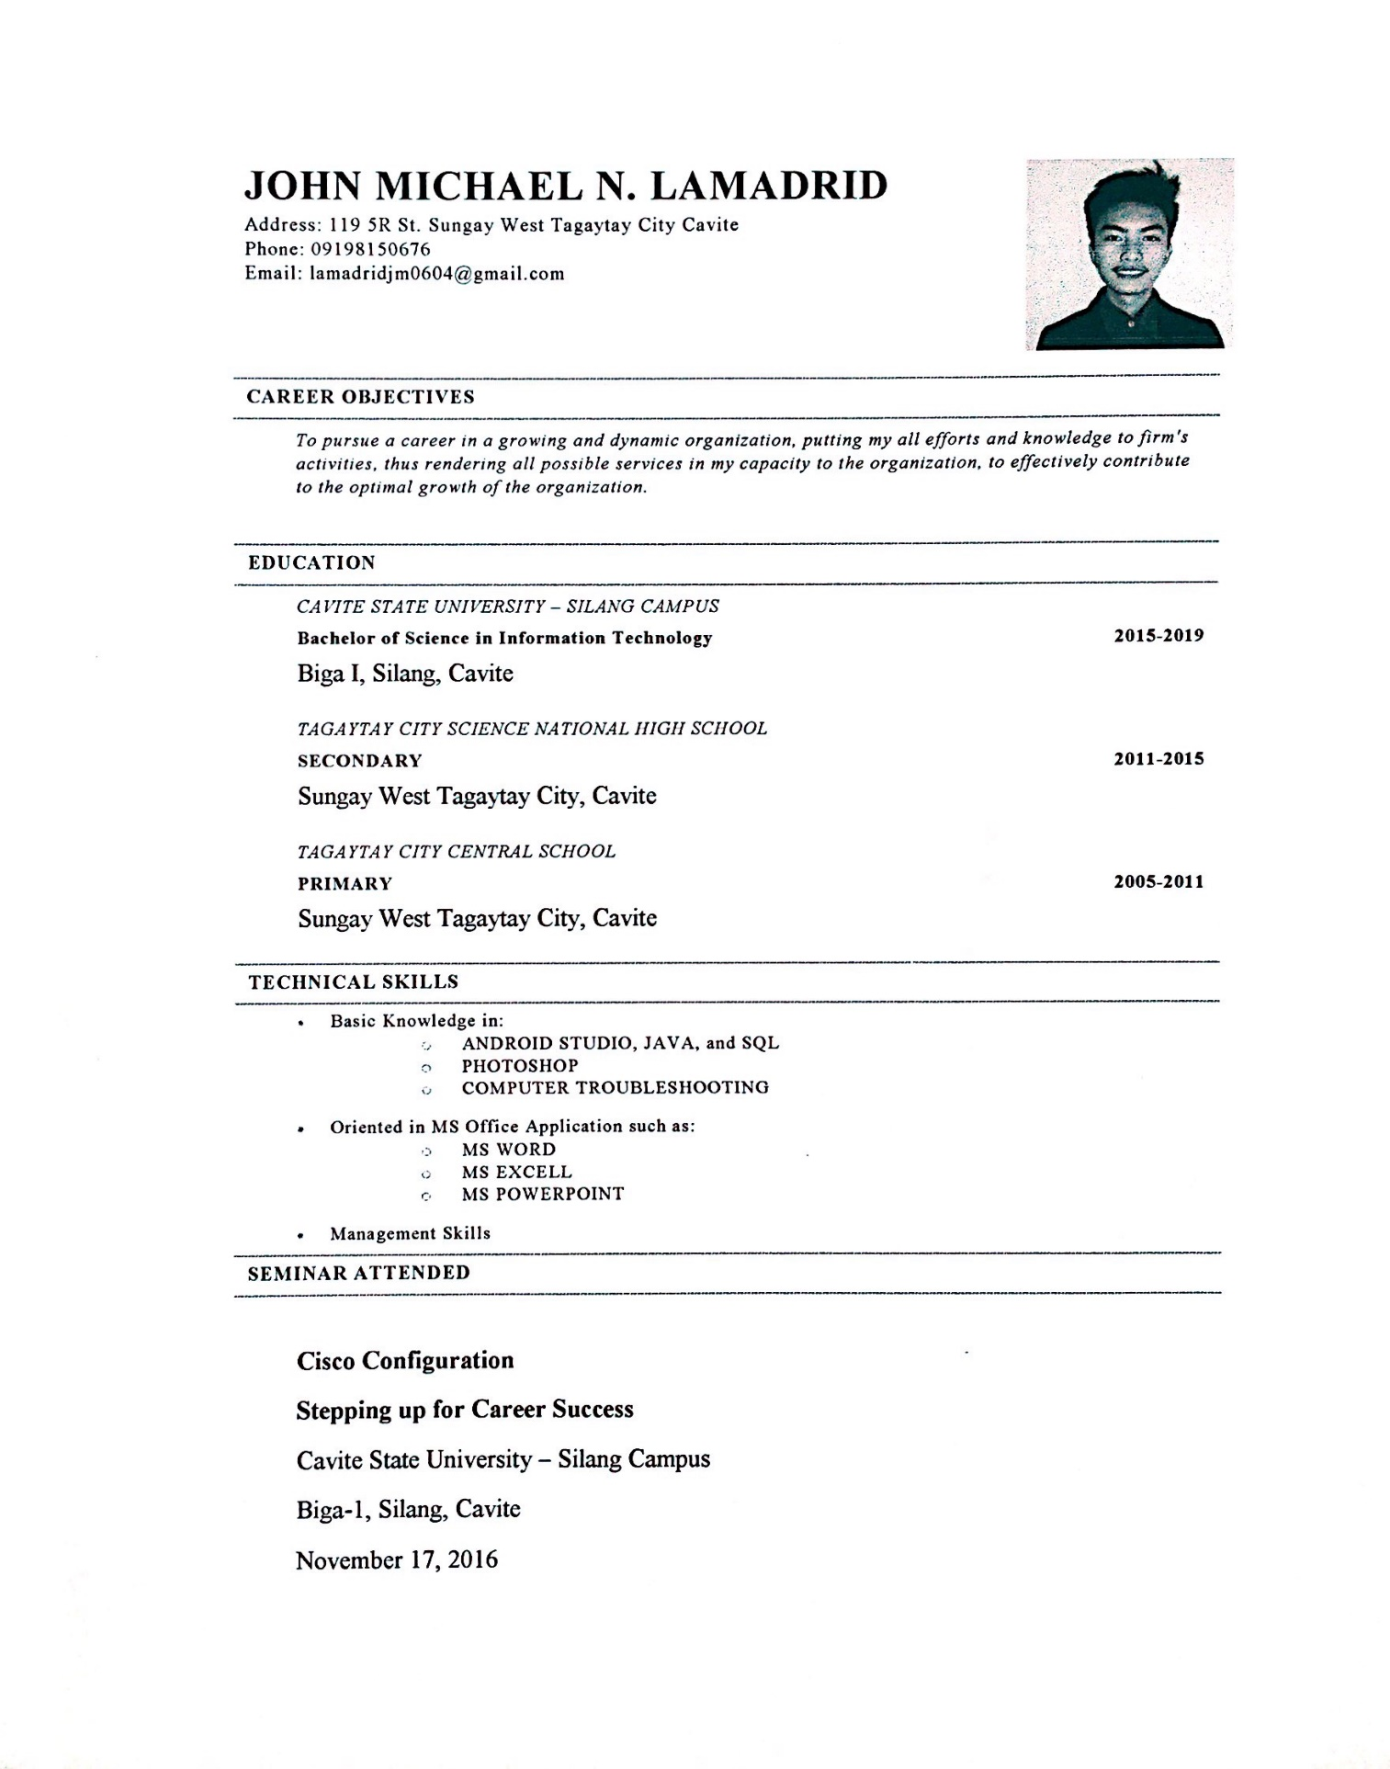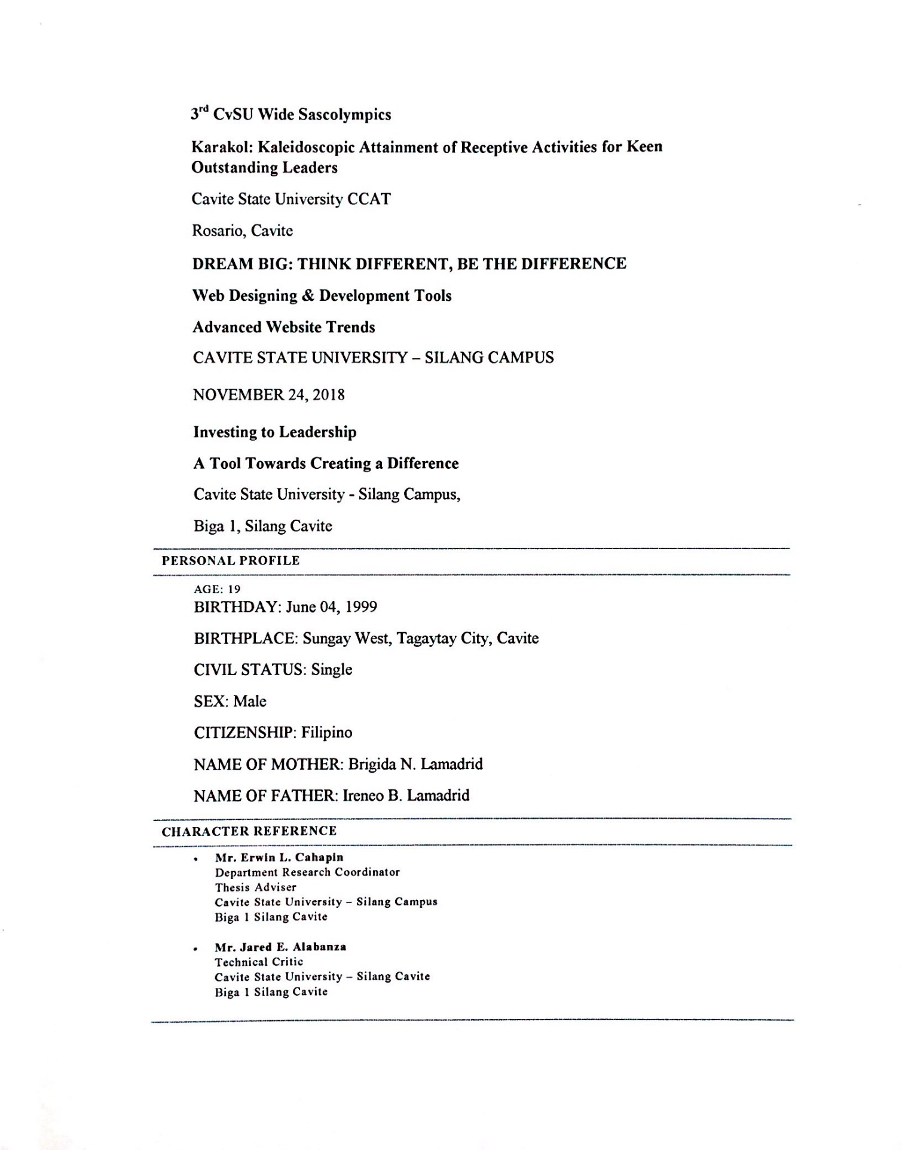

**APPENDIX H**

Photo Documentation

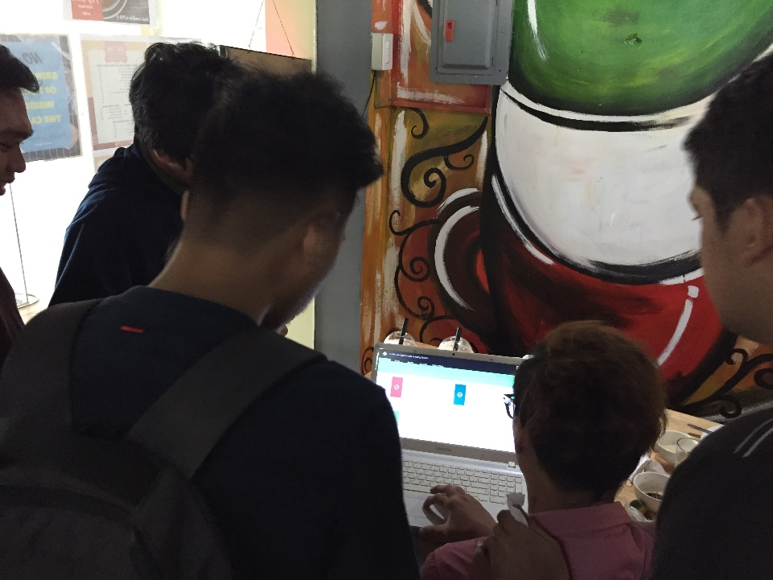

Appendix Figure 10. The researcher conducts evaluation for IT experts

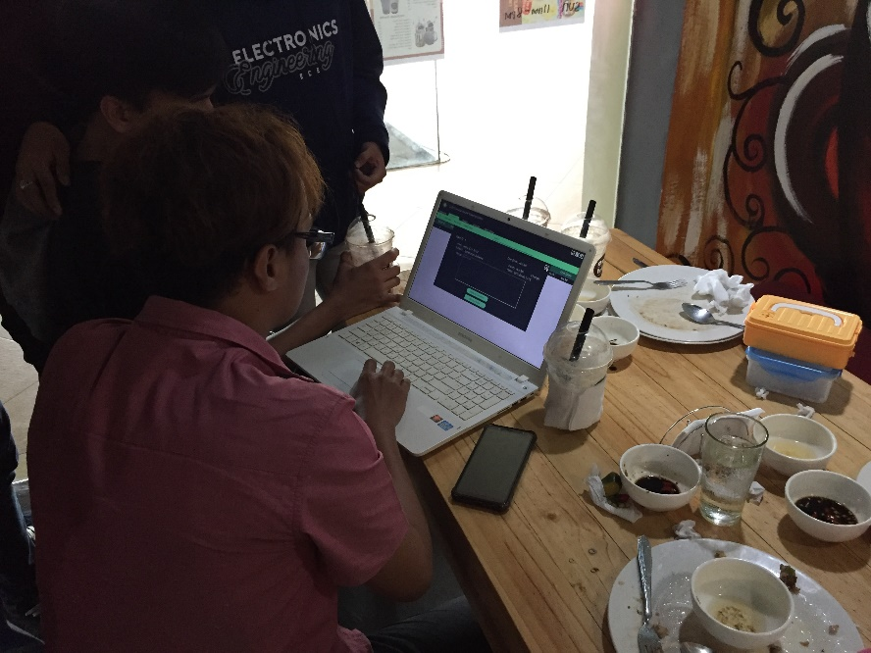

Appendix Figure 10.1 The researcher conducts evaluation for IT experts

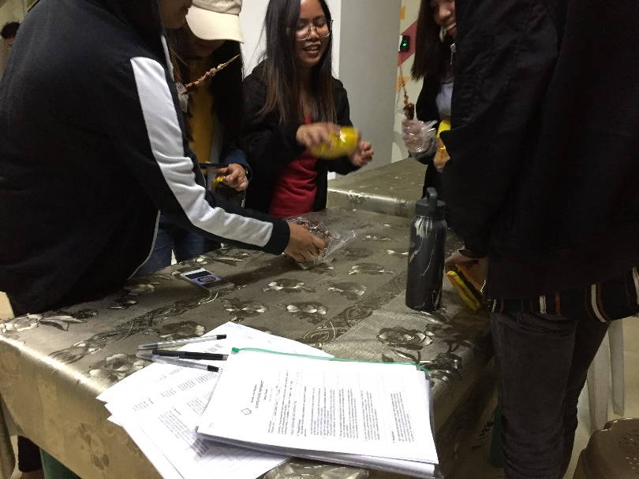

Appendix Figure 10.2. The researcher conducts evaluation for IT experts

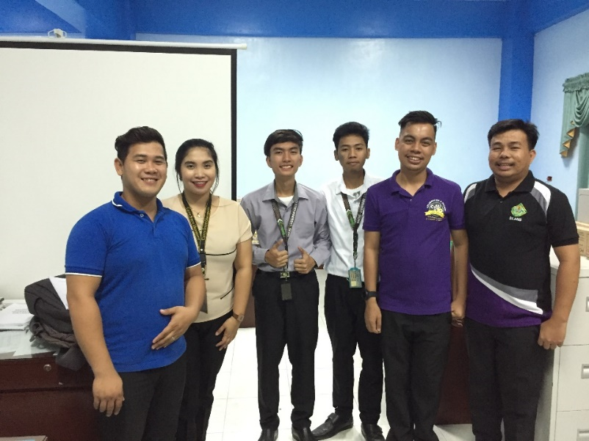

Appendix Figure 11. The researcher successfully defended their study

**APPENDIX I**

Routing Slip

